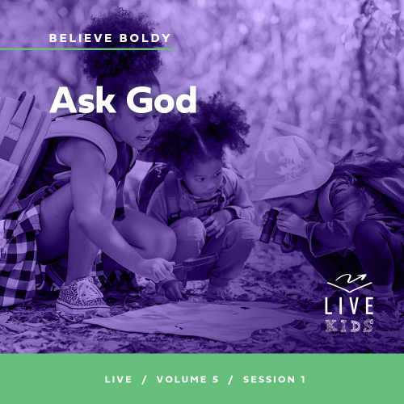Leader Overview
Volume Overview
Believe Boldly
The gospel message is shocking to many, shocking because of its implications. God has made himself known to us and promised to place His Spirit into our heart. We have been given direct access to Him. The Bible encourages us to come to Him with boldness. Our boldness in approaching Him is not from our words or our achievements. Instead, it’s based on God’s promises. So we ask, remembering His power and faithfulness. And we encourage those around us to do the same. Believe boldly.
Session Overview
Ask God
In this Live session, kids will discover that they can boldly ask God for miracles. Through the story of Bartimaeus, kids will learn that no matter how others respond to their prayers, or even discourage them, God’s goodness and heart for His people are worth pursuing boldly through prayer.
Bible Lesson
Blind Bartimaeus Calls to Jesus for Healing
Mark 10:46–52
Faith Fact
I will pray boldly.
Faith Verse
1 Corinthians 16:13–14 (NLT)
Be on guard. Stand firm in the faith. Be courageous. Be strong. And do everything with love.

Preparing for the Session
Leader Preparation Time: 20–25 Minutes
You Will Need
Large Group
- Bible
- Worship songs (Song suggestions: “Nothing Is Impossible” Lyric Video by Planetshakers; “10,000 Armies” by Influence Music; “Way Maker” Lyric Video by Leeland; “Do It Again” by Elevation Worship)
- For groups not using a phone or tablet only, add:
• Projector or TV
• Laptop
• Countdown60 Video–60 seconds
• Countdown30 Video–30 seconds
• Faith Fact Slide
• Faith Verse Video or Slide
• Bible Lesson Video
• Teaching Point Slides 1–3
- Four large bowls
- Spoons, two per volunteer
- Cotton balls, one large bag
- Blindfolds, one per volunteer
- Paper, one sheet per kid
- Pencils or pens, one per kid
Small Group
- Balloons, one per group (plus extras in case any pop)
- Countdown30 Video–30 seconds
- Bibles for kids in the group to share
- Whiteboard
- Whiteboard eraser
- Whiteboard markers
- Small Group Activity Page, one per kid
- Pencils or pens, one per kid

To access session content and videos from a computer, visit: BibleEngagementProject.com/downloads

Getting Ready
Large Group
- Download videos and slides if needed.
- Select worship song(s) and have them ready to play.
- Read the Bible Lesson Scripture to prepare for Teaching Time.
Small Group
- Inflate the balloons.
- Write the Faith Verse on the whiteboard.
- Print copies of the Small Group Activity Page, one per kid.

First time leading Live for Kids? Check out the Facilitator Guide.
Large Group
30 Minutes
See what’s needed at the beginning of the session.

Introduction
Hey, everybody! We’re going to have an amazing time together today. Everyone shout, “Believe!” (Group response) Great job! Today we’re talking all about how we can be bold and believe God will show up in our life.
Raise your hand if you’ve ever asked God for something. (Group response) That’s awesome! Asking God for things is one part of praying. We can pray boldly for God to do miracles, no matter what other people think about our prayers. Sometimes we might wonder if praying makes a difference. Have any of you ever felt that way? (Group response) Me too. But God wants to help us believe that He can do anything.
Faith Fact
Our Faith Fact today is I will pray boldly. Later we’ll see how the man in our Bible story bravely asked Jesus for what he needed, and Jesus answered in a powerful way!
• Show the Faith Fact Slide.
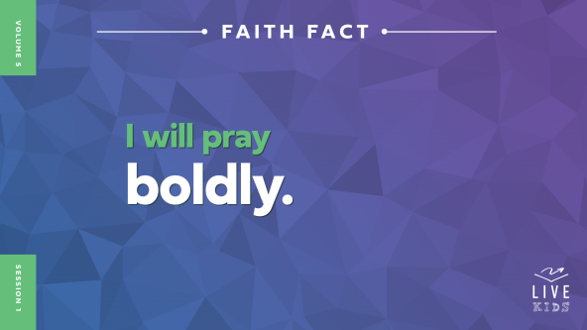
Hold your hands together like you’re praying. Now let’s say the Faith Fact together. I will pray boldly. One more time: I will pray boldly. Well done!

Game
Blindfolded Blessings
I need some bold players to come up and play a game called Blindfolded Blessings. It’s pretty challenging! It takes focus, skill, and the will to win.
• Choose two volunteers and have them come up front.
• Optional: Consider turning this into a team relay to add more excitement and increase participation.
Here’s how the game works: Each player will have two bowls in front of them, one full of cotton balls and the other empty. Each kid will be blindfolded and get a spoon. The goal is to use the spoon to move as many cotton balls as possible to the empty bowl. Whoever moves the most cotton balls in one minute will be the winner. Let’s get started!
• Start the Countdown60 Video–60 seconds.

• Play a second round if you have time.
This game was fun to watch, but it was tough to play! The cotton balls are so light, it was hard for the players to know if they had moved any until they took off their blindfolds.
Sometimes when we pray, it can feel like the words we’re saying aren’t making much of a difference—or at least not one we can see. That feeling can be tough. But even if we can’t tell, our prayers do make a difference! We’ll see today how important it is to pray boldly. Let’s say the Faith Fact together. I will pray boldly.

Worship
It’s easier to pray boldly when we remember all the miracles God has done for other people—and for us! Thinking about His power makes us want to praise Him. Who’s ready to worship God today? (Group response) One way we worship God is by singing. Let’s worship Him right now.
• Lead the kids in singing one or two praise songs. See suggestions at the beginning of the session.

Bible Lesson
Thanks for worshipping with me, everyone! Praising God reminds us how amazing He has been to us. When we remember how much God loves us, we love Him even more. And we’re encouraged to pray boldly. That’s our Faith Fact today: I will pray boldly. In a moment, we’ll see what the Bible says about praying boldly, but first let’s pray.
Prayer
Dear God, thank You for this opportunity to learn more about You from Your Word. Teach us to pray boldly and believe You can do anything. In Jesus’ name. Amen.
Video Intro
Before we look at the Bible story, let’s watch this video and see what Dash is up to.
• Play Bible Lesson Video.
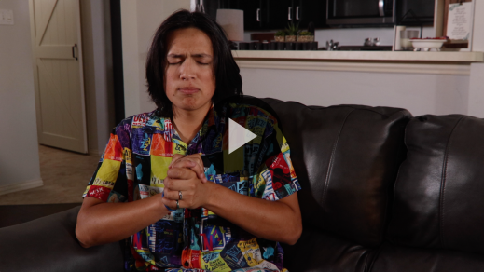
Bible Story
Blind Bartimaeus Calls to Jesus for Healing
Have you ever been in a situation like Dash when something terrible happened and all you could do was pray? (Group response) Sometimes people who don’t know God don’t understand why we pray. They might even tell us prayer doesn’t matter. Let’s take a look at our Bible story and find out what we should do when that happens.
Teaching Time
Jesus was walking out of the city of Jericho, and many people were following Him. Why do you think they did that? (Allow responses.)
There could have been many reasons the crowd followed Jesus. Some people wanted to hear what Jesus said. Some may have even realized Jesus was an important messenger from God. Others may have heard about Jesus’ miracles and wanted Him to do something for them.
People could tell Jesus was special, and they wanted to be close to Him. One person in our Bible story today was especially bold and called out to Jesus for help. That reminds me of our Faith Fact. Let’s say it together. I will pray boldly.
Now grab your Bible or pull up a Bible app on your device. Turn to Mark 10:46–52.
• In order to keep Large Group time moving along, we recommend that the leader reads the Scripture portions aloud.
• Optional: Remind the kids to mark this place with a bookmark, so they can read it on their own at home.
- Bartimaeus boldly called out to Jesus.
• Show the Teaching Point 1 Slide.
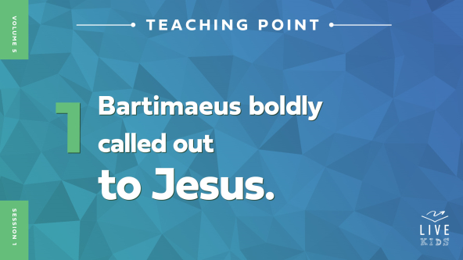
• Read Mark 10:46–47.
Bartimaeus was sitting beside the road outside Jericho, and he called out to Jesus for mercy. Bartimaeus was blind, which means he couldn’t see. Do you think Bartimaeus believed that Jesus would heal his eyes? (Group response) In those days, not being able to see also meant Bartimaeus couldn’t work. He had to beg to get money to buy food, clothes, or a place to live. Asking Jesus for mercy meant Bartimaeus believed Jesus could help with his problems.
Of course, Bartimaeus couldn’t see Jesus coming. Instead, he heard that Jesus was near. Without knowing exactly what was going on around him, Bartimaeus started yelling, “Jesus, Son of David, have mercy on me!” That was bold. It was loud. And Bartimaeus wasn’t embarrassed. Why do you think Bartimaeus was so bold? (Allow responses.)
Imagine Dash came into the room right now and said, “Whoever is the boldest and loudest can compete against me in a million-dollar challenge video.” Show me what you would do! (Group response) Wow! You must really want to be a part of that challenge video.
Why did you get so loud and bold? (Group response) Yes, it was a big opportunity! Who cares what the person next to you thinks if you have a chance to win a million dollars, right? In the same way, Bartimaeus knew this was a once-in-a-lifetime opportunity. It was possible his vision could be restored and he would meet the Messiah—the Promised One! That opportunity was worth being bold for. But believe it or not, some people didn’t like what Bartimaeus was doing.
2. Bartimaeus wouldn’t stop calling out to Jesus.
• Show the Teaching Point 2 Slide.
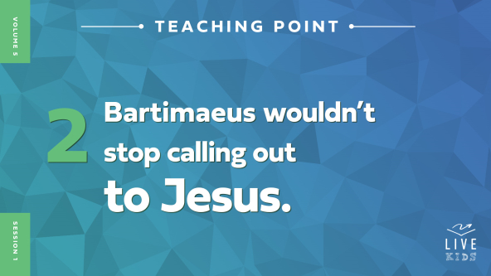
• Read Mark 10:48–49.
Did you hear that? (Group response) Some people in the crowd told Bartimaeus to be quiet instead of calling out to Jesus! It seems unbelievable. But sadly, we might do the same thing sometimes. It can be easy to look at someone who needs help and not care that much about what they’re going through. Why do you think the people in the crowd did that to Bartimaeus? (Allow responses.)
The people’s unkindness didn’t stop Bartimaeus. Instead, he became bolder and louder and kept calling out to Jesus—the only One who could help him the most. Even when other people tried to make Bartimaeus be quiet, he didn’t want to miss this opportunity. He needed to get Jesus’ attention no matter what.
Let’s go back to our imaginary competition with Dash. If you won that challenge and got a million-dollar prize, what would you buy first? (Allow responses.) Those are all great ideas! Now picture that prize in your mind. And imagine again Dash saying, “The first person to the stage gets the chance to win a million dollars. Go!”
• Some kids will likely run up to the front. Be ready for this!
Look at the boldness! That’s awesome! All right, everyone, take a seat.
You showed so much boldness because it seemed like a big opportunity. Now think about the opportunity Bartimaeus had when Jesus was walking by. Jesus could heal people and do miracles. That’s why Bartimaeus was so bold! What’s amazing is that Jesus not only heard Bartimaeus, but He told the crowd to call Bartimaeus forward. Bartimaeus’ boldness made a difference!
3. Jesus healed Bartimaeus.
• Show the Teaching Point 3 Slide.
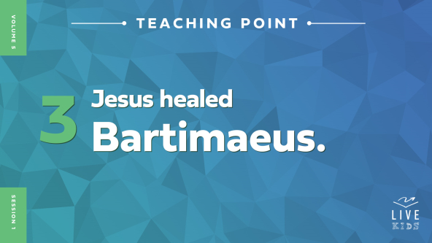
• Read Mark 10:50–52.
Isn’t it amazing that Jesus asked Bartimaeus what he wanted Jesus to do for him? Bartimaeus boldly and honestly answered Jesus, and right away, Bartimaeus could see! Jesus healed him! Everyone, stay near your seat and show me how you would respond if you were healed like Bartimaeus was.
• Give kids a few moments to respond enthusiastically.
Wow! Bartimaeus was so full of thanks after being healed that he decided to follow Jesus. What an awesome story! Now, we don’t really have the chance to go up to Jesus in person like Bartimaeus did, so how can we be bold in asking Him for help? (Allow responses.)
Prayer is simply talking to God and then listening for Him to speak to our heart and mind. That’s how we ask for God’s help. We don’t need to be afraid to ask. Instead, we can be bold! Jesus healed Bartimaeus’s eyesight after he told Jesus what he needed. And we can ask boldly too—for healing, for protection, for joy, and for anything else we need! When we’re praying to God, no question is too big or too small.
Do we always get everything we pray for? (Group response) No, we don’t. It might be hard to understand, but God doesn’t give us whatever we want. When it’s almost Christmas or your birthday, you might make a list of all the presents you can think of. But you probably don’t get everything on your wish list. When God doesn’t answer our prayers like we want, that doesn’t mean God is limited. It means He knows what we really need and exactly when we need it.
Remember our Faith Fact today: I will pray boldly. When we pray, God hears us. So let’s be bold like Bartimaeus and ask for help. God knows what we need, and we can trust Him.

Prayer and Response
Consider playing a worship song softly in the background while kids pray.
Bartimaeus showed us how to boldly ask for help. He didn’t care too much about what other people thought, and he had faith in Jesus. Sometimes, we go through hard times too, and we need God’s help. So today, we’re going to boldly pray and ask God for miracles. No matter what other people think, we can be brave and ask God for things we need. We know He hears us and cares for us.
Before we pray, I’ll give you a piece of paper. Then, I want you to write down a situation you can boldly pray about this week.
• Hand out a sheet of paper and a pencil or pen to each kid.
As we pray, we’ll ask God two questions: What do you want me to pray boldly for? And how can I pray boldly for it? Ask God these questions, either with your voice or in your mind, and then listen carefully to the thoughts in your mind and your heart. That is often how God speaks to us.
Maybe the answer in your mind or heart might seem kind of small—like praying for your brother to find his lost LEGO minifigure or praying that you won’t get another flat tire on your bike. Or maybe what you’re going to pray boldly for is huge—like praying that a sick family member would be healed or praying that your friends at school would stop talking about you behind your back. After you know what you are going to pray for, write it down. Then if you’re comfortable, find a leader or friend to share it with. When we share what God tells us, it helps us remember what He said.
• Give kids time to pray and respond. Then pray together.
Prayer
Optional: Have the kids repeat phrases of the prayer after you.
Dear God, thank You for hearing us when we boldly pray. We want to honor You in everything we do, and we want You to answer our prayers. Help us to be fearless when we pray, and help us to not worry about what others think. We call on You, because we believe You can help us. In Jesus’ name. Amen
Faith Verse
Our Faith Verse is all about being bold and courageous and doing everything with love. It’s a great reminder as we learn to pray boldly.
• Play Faith Verse Video.
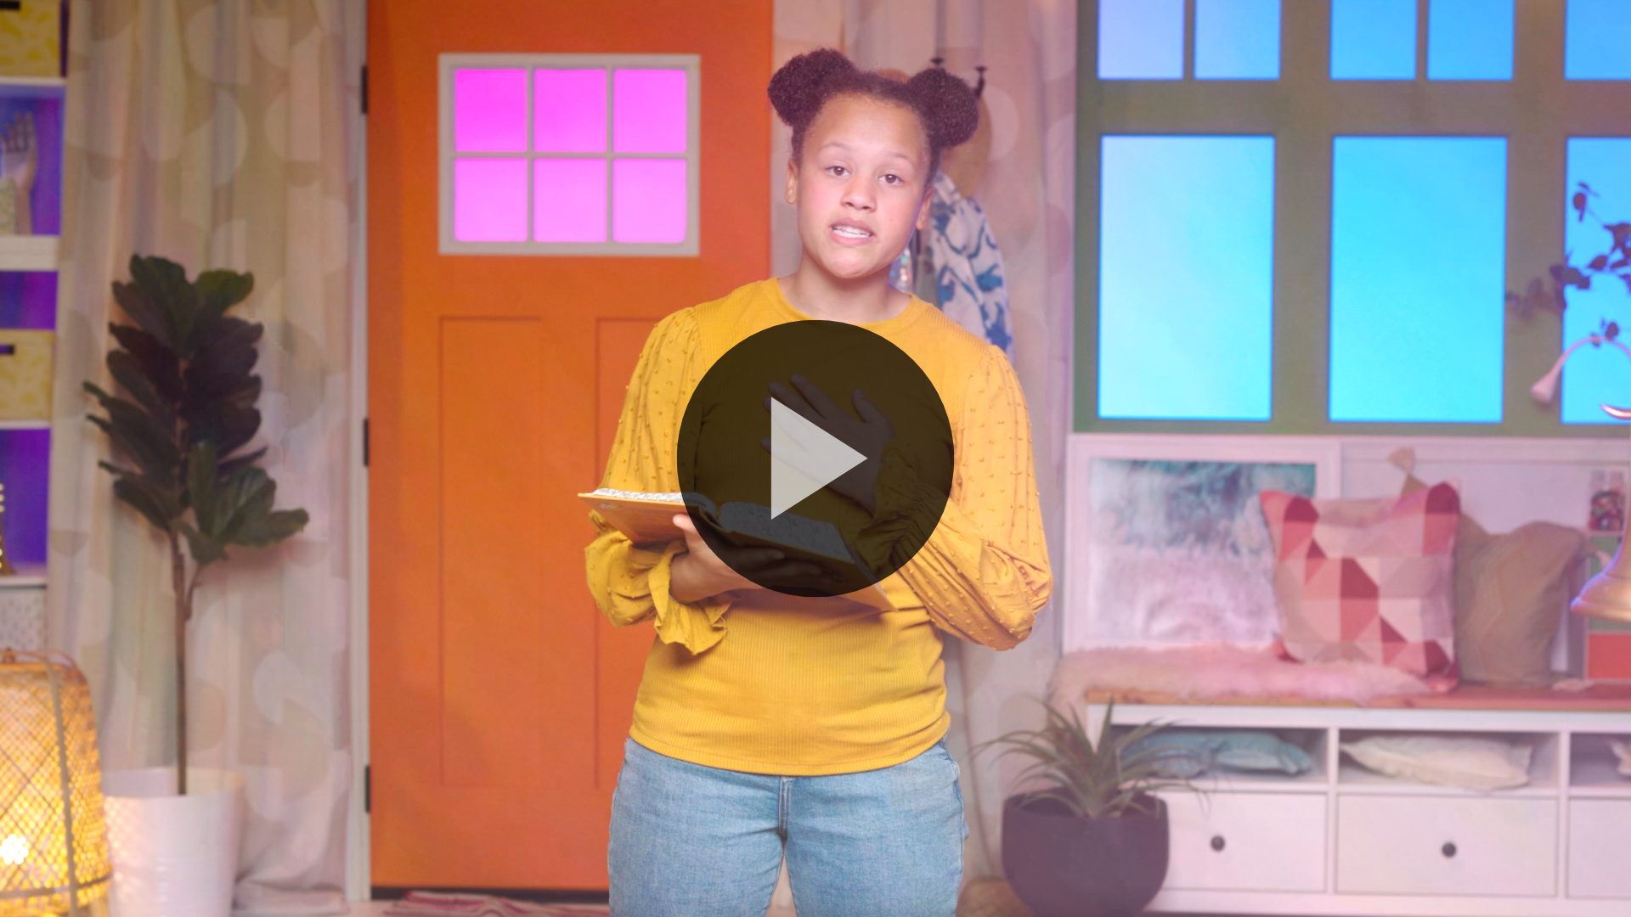
1 Corinthians 16:13–14 (NLT)
Be on guard. Stand firm in the faith. Be courageous. Be strong. And do everything with love.
Let’s say that verse again, all at once. (Group response) Great work!
Faith Fact
Before we move on, let’s review our Faith Fact. I will pray boldly.
• Show the Faith Fact Slide.
Look around the room, and point at someone you can pray for. Now let’s say the Faith Fact together. I will pray boldly.
• Dismiss kids to Small Group time or to go home if your group time ends here.

Small Group
30 Minutes
This section can be done in conjunction with the large group or on its own if you do small groups with your kids. During Small Group time, the goal is to connect the kids with the Word of God and to each other. All activities are led by the small group leader.

Group Connection
Balloon Bounce and Share
You Will Need
- Balloons, one per group (plus extras in case any pop)
- Countdown30 Video–30 seconds
Getting Ready
- Inflate the balloons.

In our Bible story today, Bartimaeus wasn’t afraid to ask boldly for Jesus’ help, even though others told him to be quiet. Instead of listening to the crowd, Bartimaeus stood firm and called out boldly. And Jesus heard him and answered his prayer!
Let’s play a quick game that will help us learn to speak up without fear! Here’s how the game will work. One at a time, each person will need to keep the balloon off the floor for 30 seconds. As you’re hitting the balloon, tell us about your favorite hobby or about something great that’s happened in your life lately.
• Start the Countdown30 Video–30 seconds.

• Repeat as needed until everyone has a chance to share.

Bible Lesson Recap
• If small group activities are not immediately following large group time, you may want to read the Bible story passage before the discussion.
You Will Need
- Bibles for kids in the group to share

No prep needed for this activity.
Bible Story Review: Blind Bartimaeus Calls to Jesus for Healing Mark 10:46–52
What was the most interesting part of today’s Bible story? (Allow responses.) Those are great answers! To review, Bartimaeus was a man who was blind and he boldly asked Jesus for help. Other people told Bartimaeus to be quiet and stop bothering Jesus. But Bartimaeus boldly told Jesus what he wanted, and Jesus healed him.
Why was it so important that Bartimaeus was bold? (Allow responses.) Remember, Bartimaeus couldn’t see, so he couldn’t find his way through the crowd to run up to Jesus. Instead, he had to get Jesus’ attention by calling out to Him. Bartimaeus’s boldness showed that he believed Jesus could help him. It didn’t matter what the other people thought about him; Bartimaeus knew he just needed to get to Jesus.
• Give each kid a Bible and read the Bible story together.

Group Discussion
Feel free to use all or just a few questions as a jumping-off place for good discussion. Questions marked with * are designed for more conversation. Adjust the questions based on the age or maturity of your group. Typically, older kids will be able to dive a little deeper than younger ones.
Questions
Why was the crowd following Jesus in the first place?
* What do you think life was like for Bartimaeus before Jesus healed him?
Why did the people tell Bartimaeus to be quiet?
* Do you think you would have been bold like Bartimaeus? Why or why not?
* How can we be bold when we ask God for help?
Why do you think Bartimaeus followed Jesus after he was healed?
How do you think Bartimaeus would have responded if Jesus had ignored him or decided not to heal him?
* When have you seen someone be bold? What were they doing or saying to show they were bold?
* Is there something you are scared to ask God for? What makes you afraid to ask?
* What is something you can boldly ask God for this week?

Live It
Faith Fact
Our Faith Fact is I will pray boldly. Bartimaeus showed us what can happen when we boldly ask God for what we need. Earlier we wrote down some things that we want to pray boldly for. To help us show that boldness, I want to invite you to share what God told you to pray for—if it’s not too private to share. Then we’ll take some time to pray together for that situation. Praying with others can help build our faith to believe boldly together.
• Share needs and pray over them with boldness.
Challenge
The challenge for this week is to pray for the need God gave you. Consider sharing it with your family and asking them to pray boldly with you. As we bravely bring our needs before God, He will do amazing things!
Prayer
Finish group discussion by sharing prayer requests and praise reports. Keep track of your small group’s prayer requests and review them each time you meet.
• Have kids share and pray for each other’s prayer requests.
Dear God, thank You for hearing us when we pray. Please help us to be bold when we bring our needs to You. Help us to trust that You will give us what we need when we need it. In Jesus’ name. Amen.

Faith Verse Review
You Will Need
- Whiteboard
- Whiteboard markers
- Whiteboard eraser
Getting Ready
- Write the Faith Verse on the whiteboard.

Our Faith Verse is 1 Corinthians 16:13–14. God wants us to do everything in love. As we do that, we become strong, brave, and bold in our faith. Let’s go over the verse together.
• Show Faith Verse Video.
1 Corinthians 16:13–14 (NLT)
Be on guard. Stand firm in the faith. Be courageous. Be strong. And do everything with love.
When we are courageous, we pray boldly and aren’t afraid to bring our needs to God. Let’s review our Faith Verse as a group a couple of more times. Try to memorize it as best as you can, because you need to know it for the Faith Verse game.
• Say the verse as a group a couple of times.
Faith Verse Fun
Word Wipeout
All right, now it’s time to see how well we know the Faith Verse. The Faith Verse is written on this whiteboard, and we’re going to take turns erasing one word at a time as we say it together. Let’s see if we can learn the whole Faith Verse!
• Have kids erase one word or phrase so the group can say the verse. Continue until all words are erased.
Great job, everyone! Memorizing this Faith Verse will help you be bold in your faith.

Activity Page
Word Puzzle
You Will Need
- Small Group Activity Page, one per kid
- Pencils or pens, one per kid
Getting Ready
- Print copies of the Small Group Activity Page, one per kid.
Our Faith Fact is I will pray boldly. We’ve already talked about what we can pray boldly for this week.
• Hand out a copy of the Small Group Activity Page and a pencil to each kid.
This page lists things we can boldly pray for. Let’s read them together. (Group response) Your challenge is to write the words in the spaces. If you get all the words in the right places, the circled letters should spell out our Faith Fact. Let’s see how fast you can figure out these words!

Dismissal
When we’re following Jesus and living by what the Bible says, we have a good reason to be courageous. We can pray boldly because we belong to God!
Prayer
Dear God, please help us to pray boldly for what we need and trust that You hear us. You know what we need. And You love us. Help us trust You in every situation, no matter what we’re facing. In Jesus’ name. Amen.
Faith Fact Recap
• Show the Faith Fact Slide.
Remember that God doesn’t just want me or someone else to pray boldly. He wants you to do it too! Remember the Faith Fact? Let’s say it together! I will pray boldly. I’m so glad you came today. I can’t wait to see you next time.
• Send home the Small Group Activity Page.
• Remind parents that there are Family Devotions available on the app to do with their kid.
• Tell everyone the date and time for the next session.

